Develop an app using Watson IoT Platform

Bluemix Lab Guide



Experience the power of IBM Bluemix

Pre-work

Table of Contents

Bluemix account creation 3

PART 2: Install IoT Starter App on your smartphone 16

# Bluemix account creation

This step aims to create an account for Bluemix that provides 30-day trial for free. With this trial program, you can get access to 2GB of runtime and container memory to run apps, unlimited IBM services and APIs, and complimentary support. Please be prepared for a personal email account to get the 30-day trial for this Lab.

1. Go to http://bluemix.net in your browser. https://console.ng.bluemix.net/?direct=classic

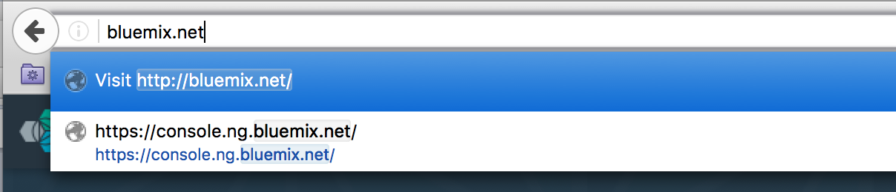

1. Click **SIGN UP** at the right top corner.

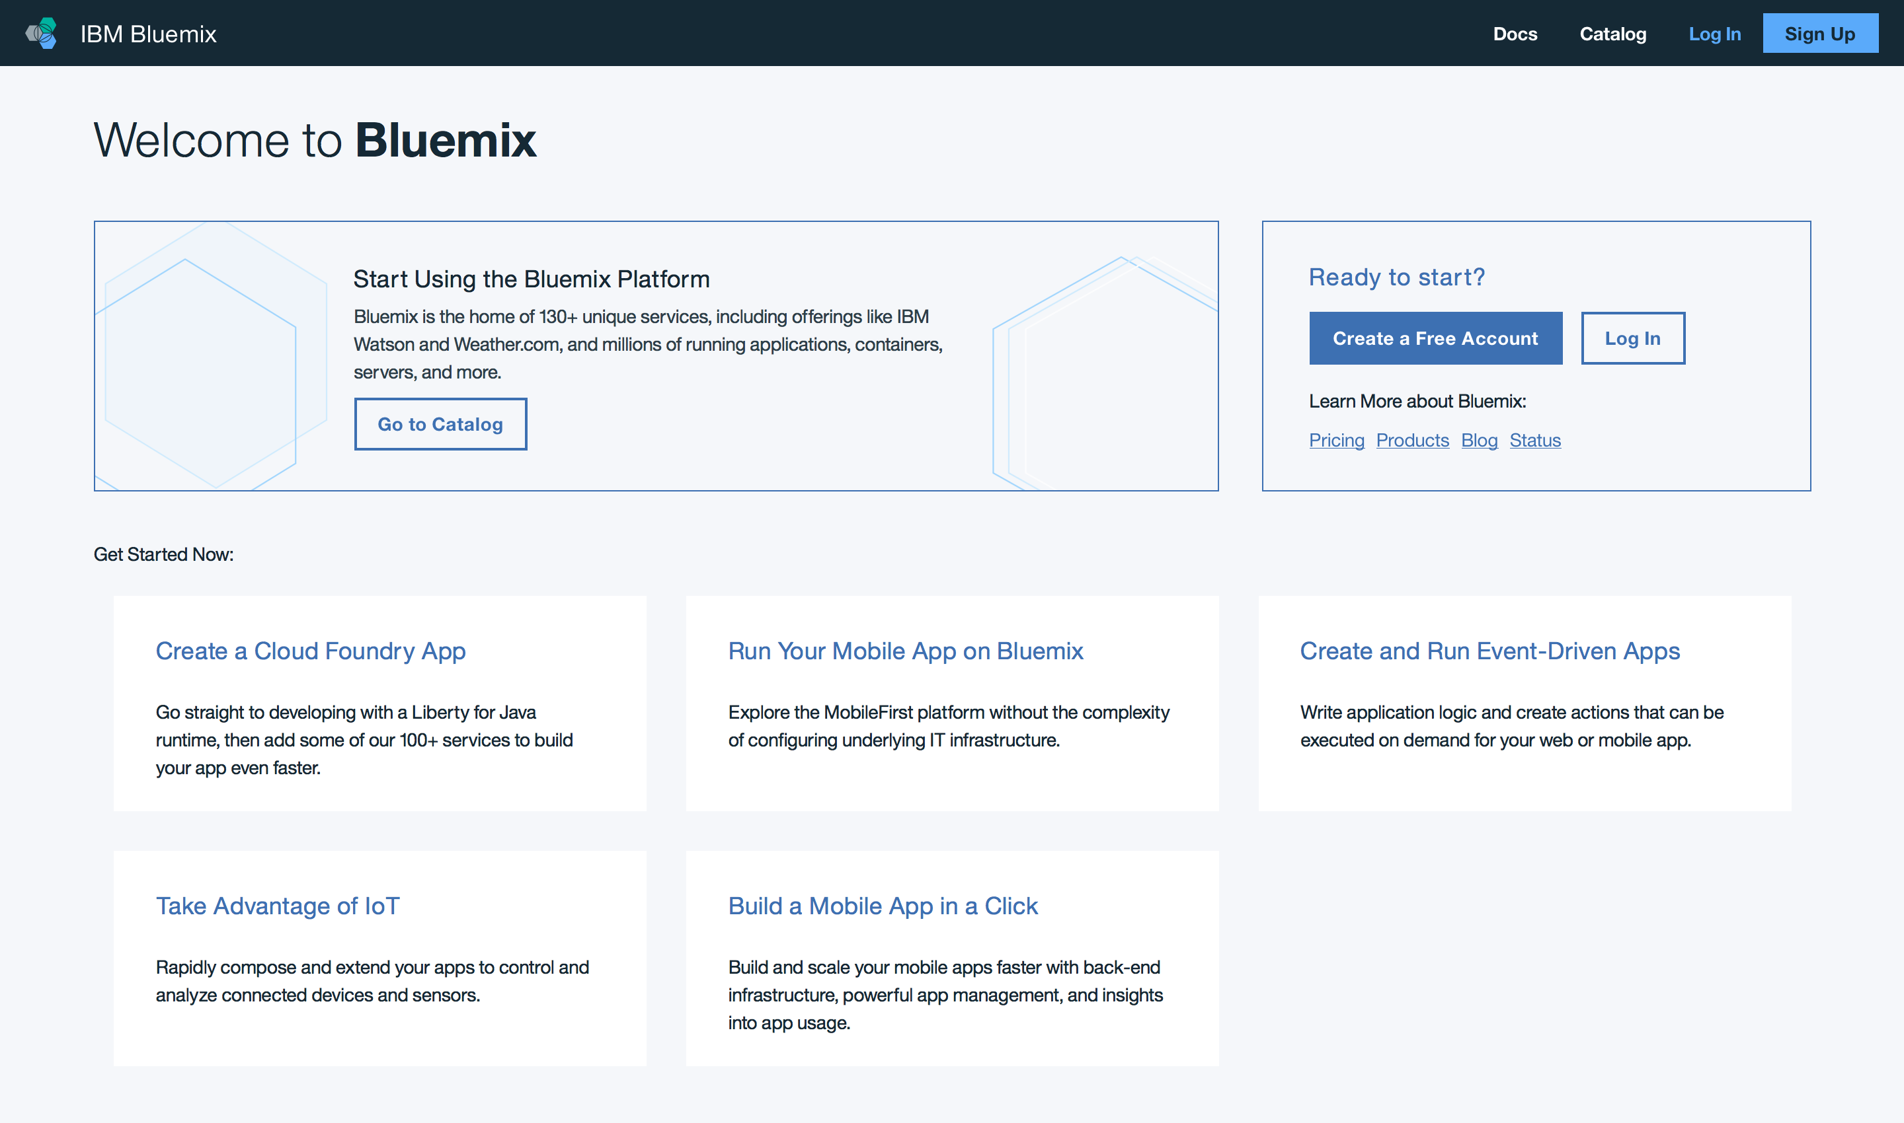

1. To fill in the form, input Email Address first. Use of personal email(ex. gmail account) is recommended.

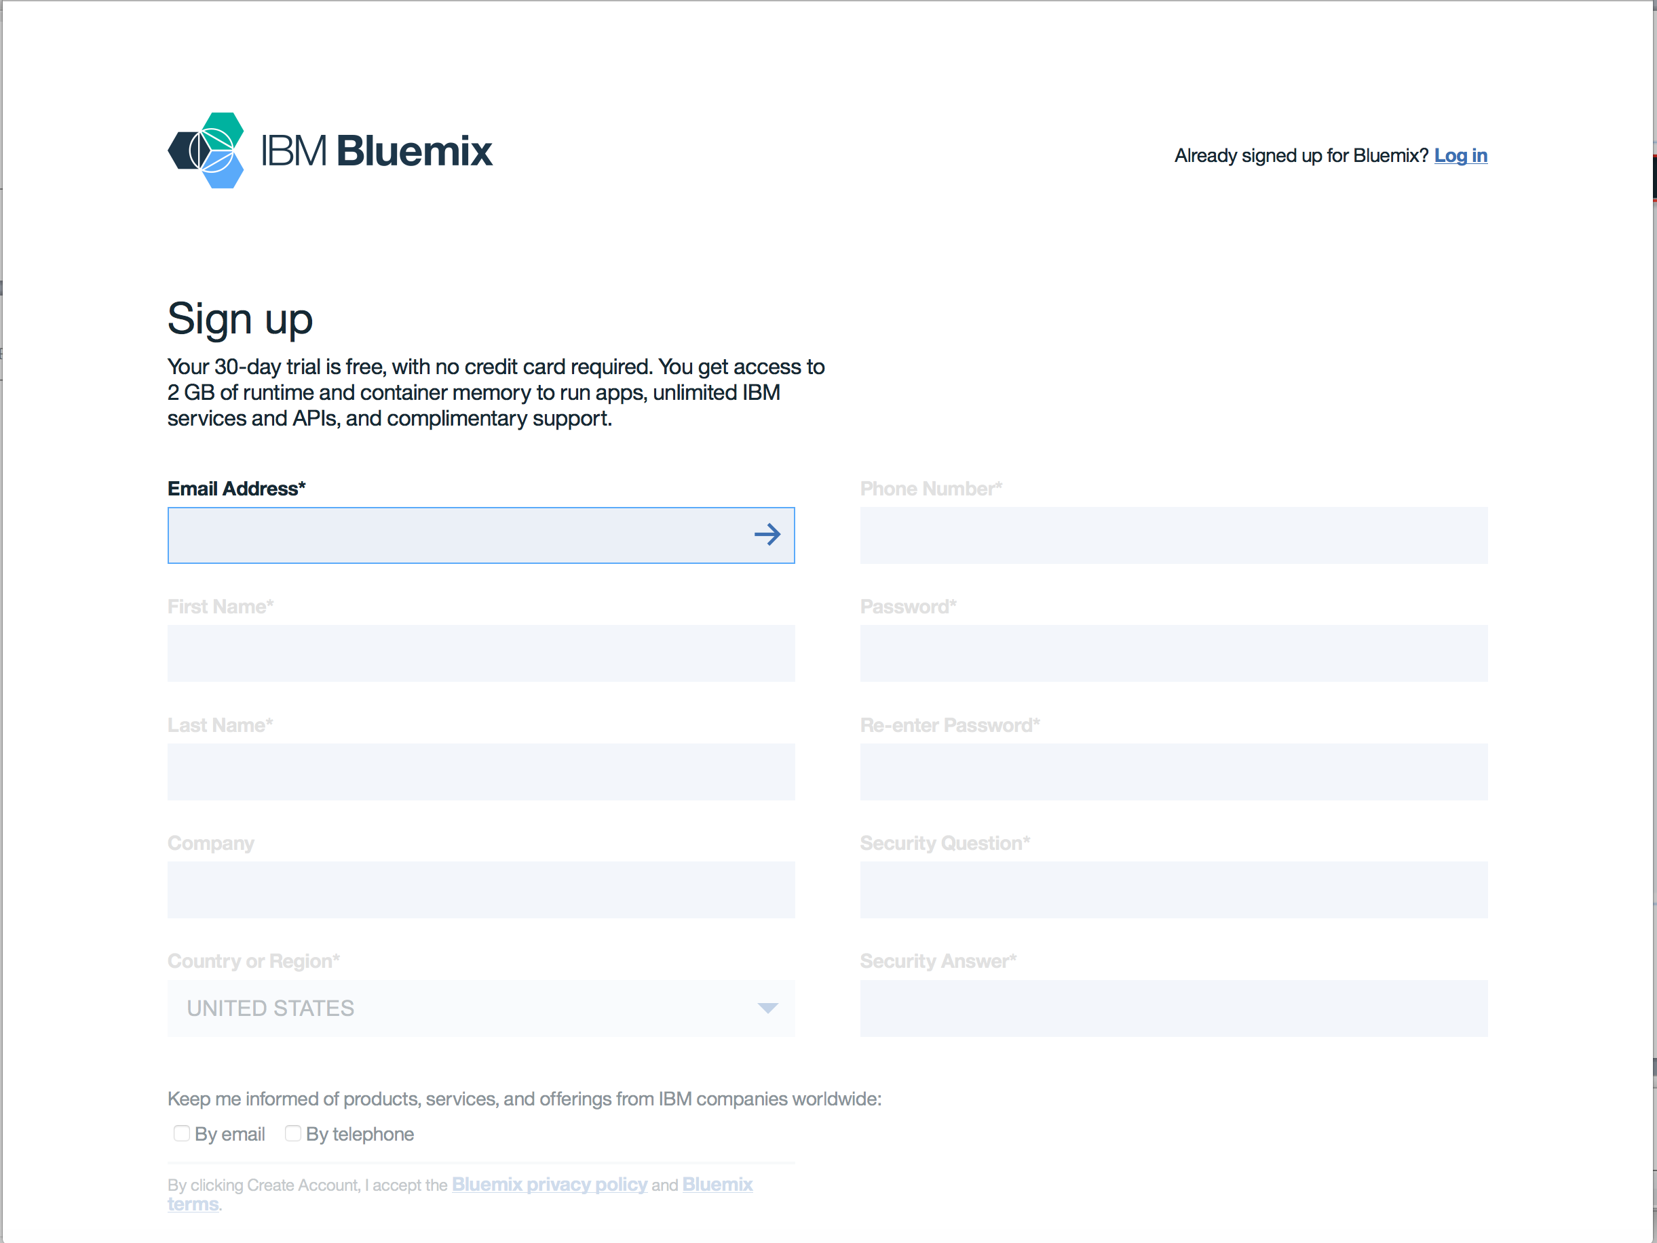

1. Press **Tab** or click **right arrow** at the input field once you finish to input your Email address, then other fields will be activated.

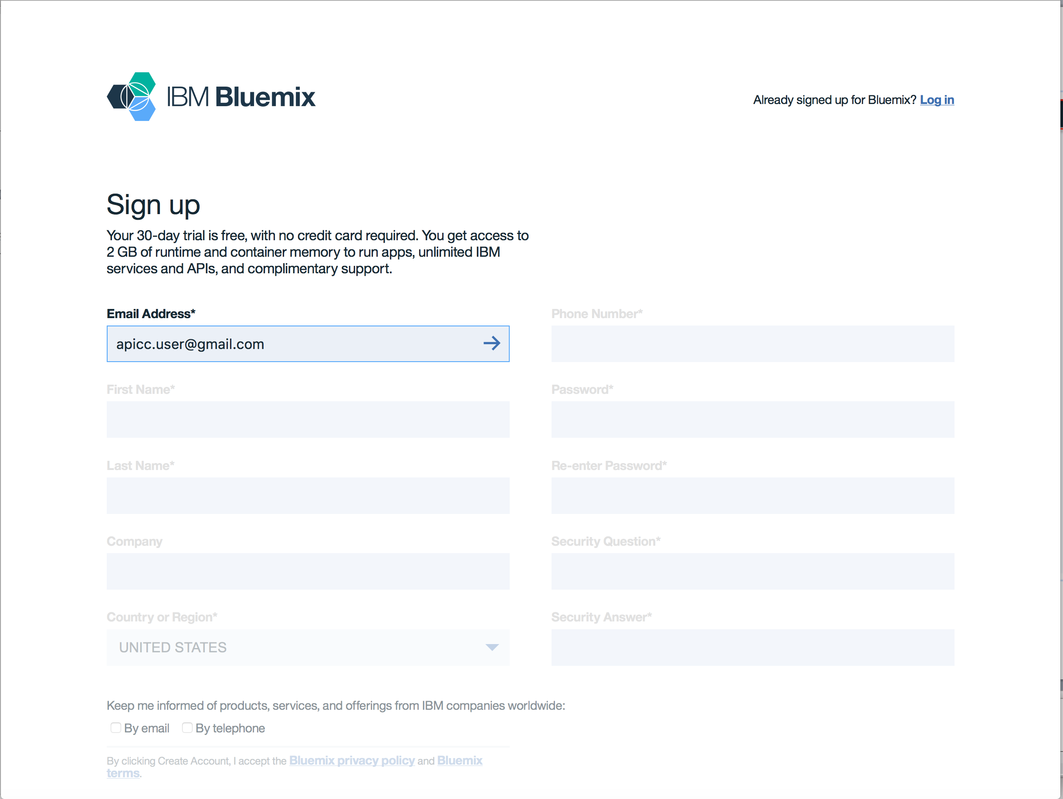

1. Fill in all fields and click **Create Account**.

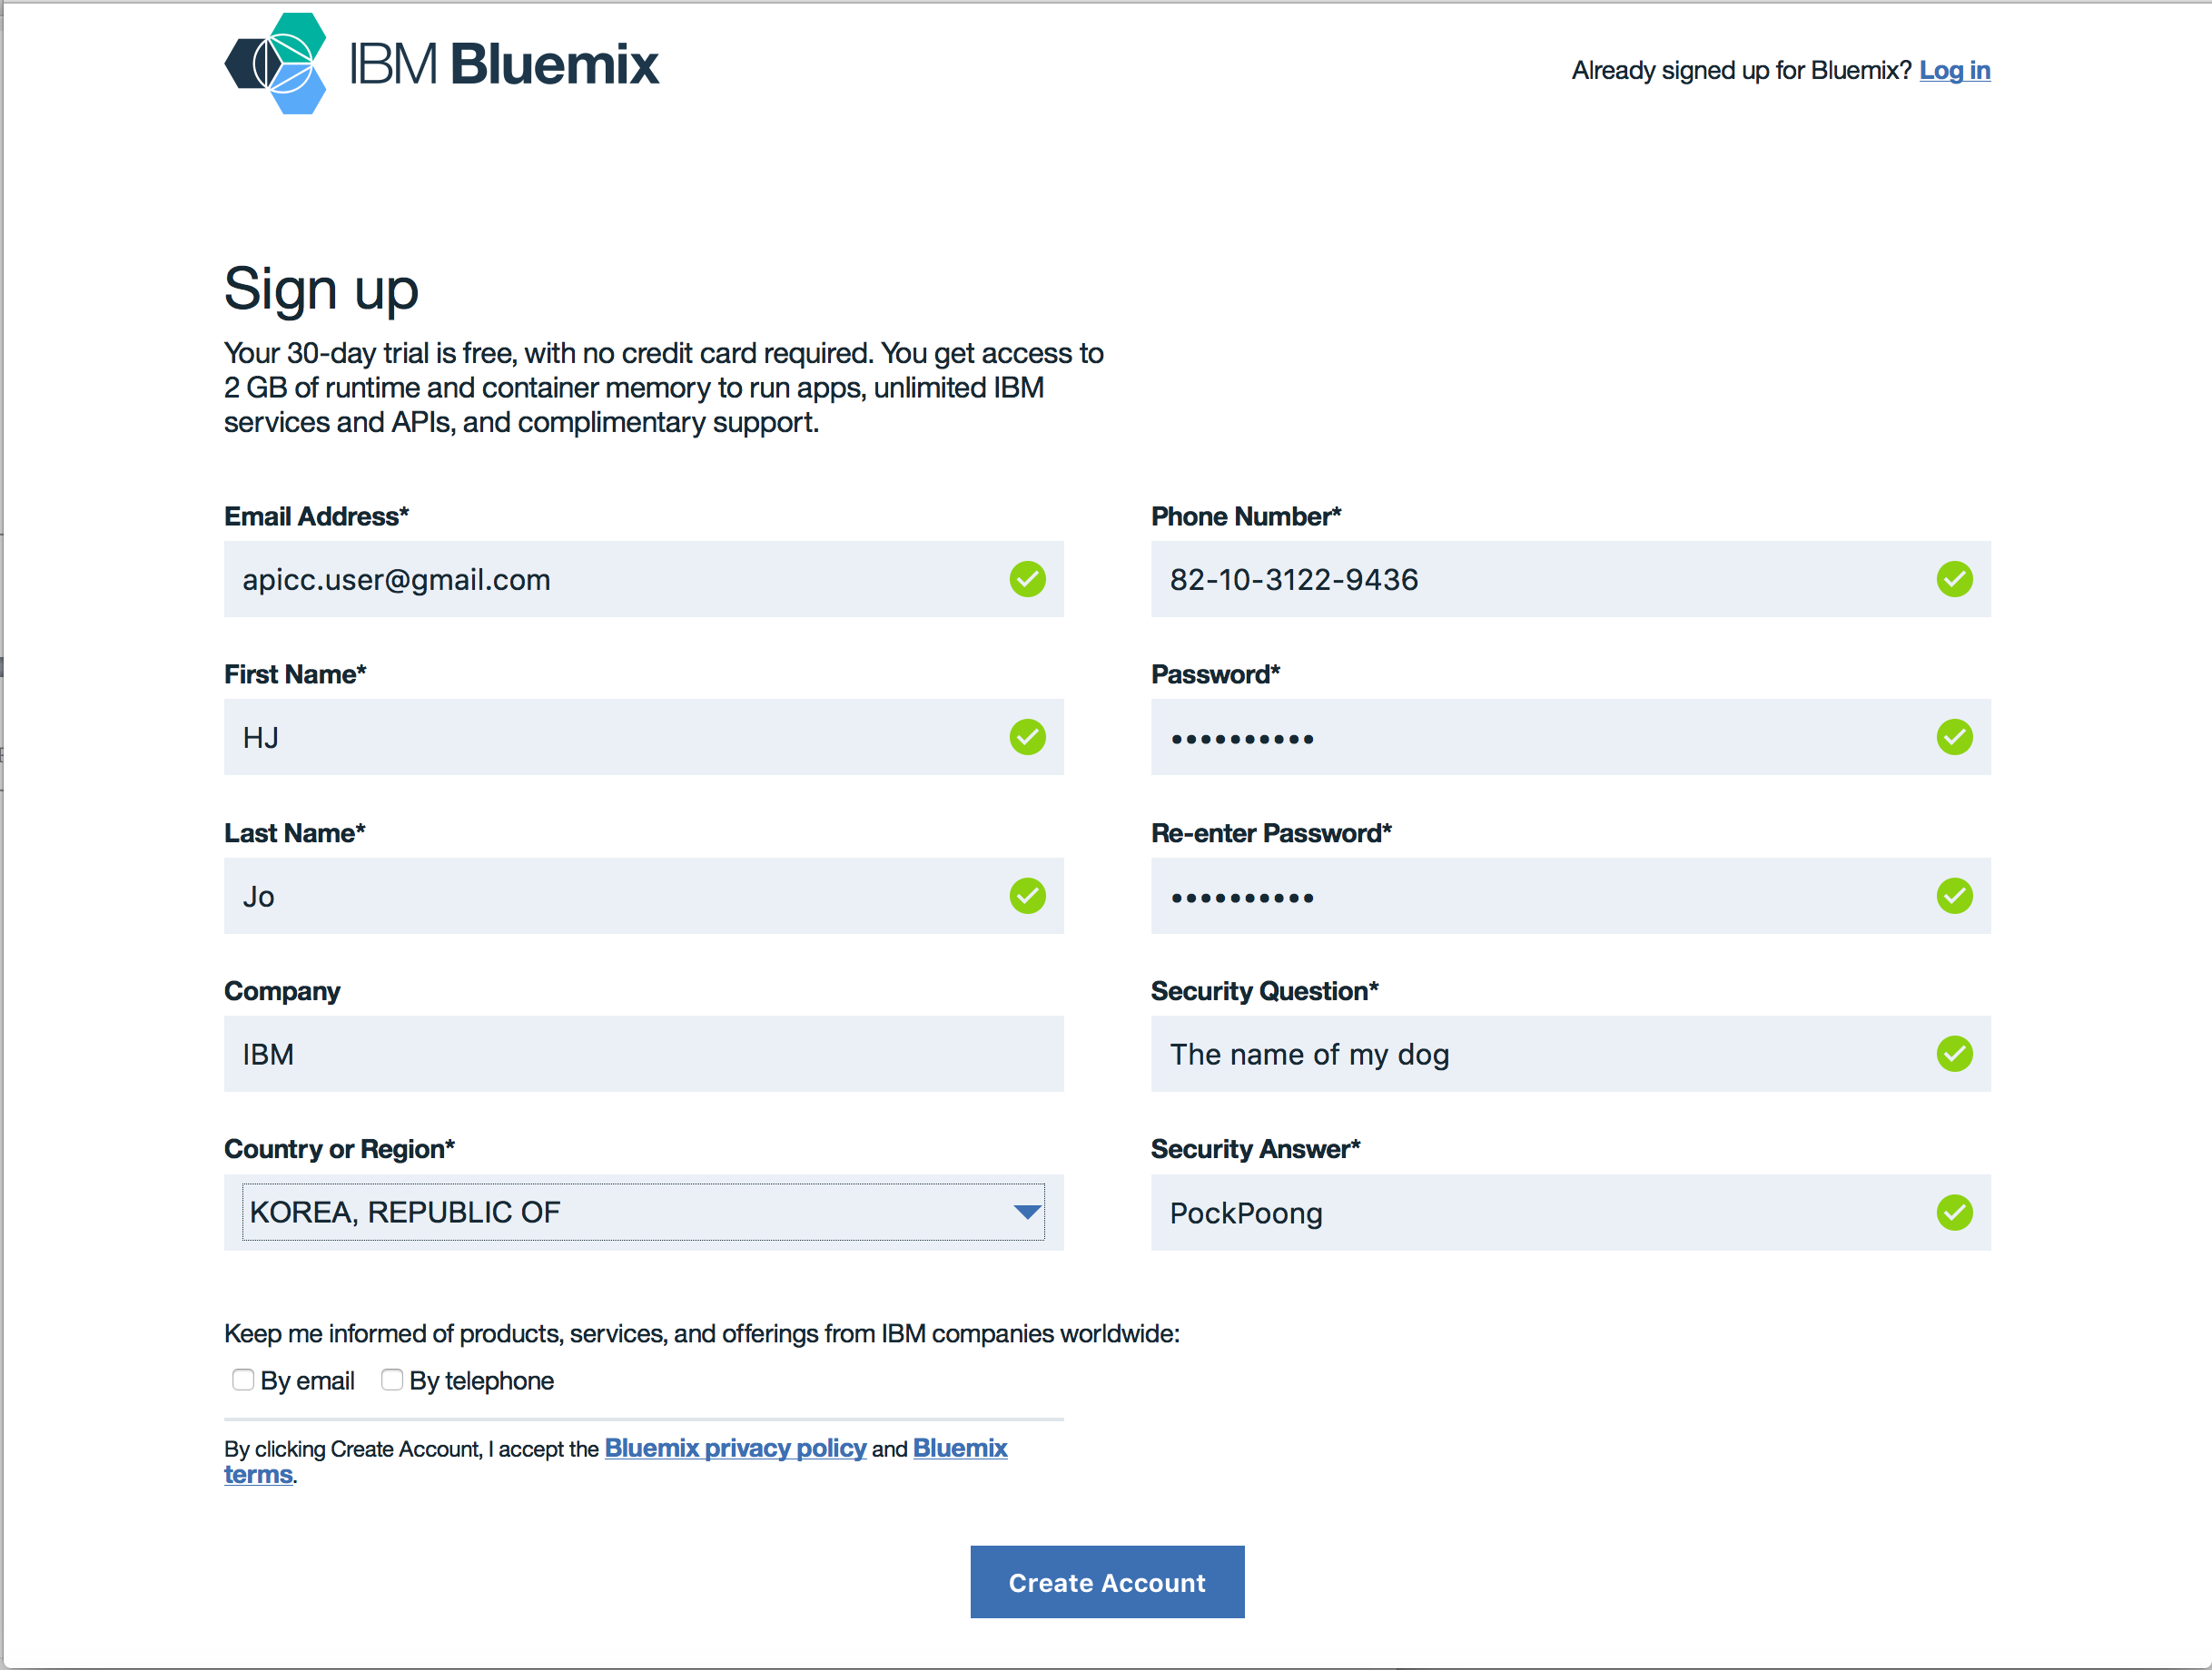

1. Almost done but have to validate your email address. Check your email.

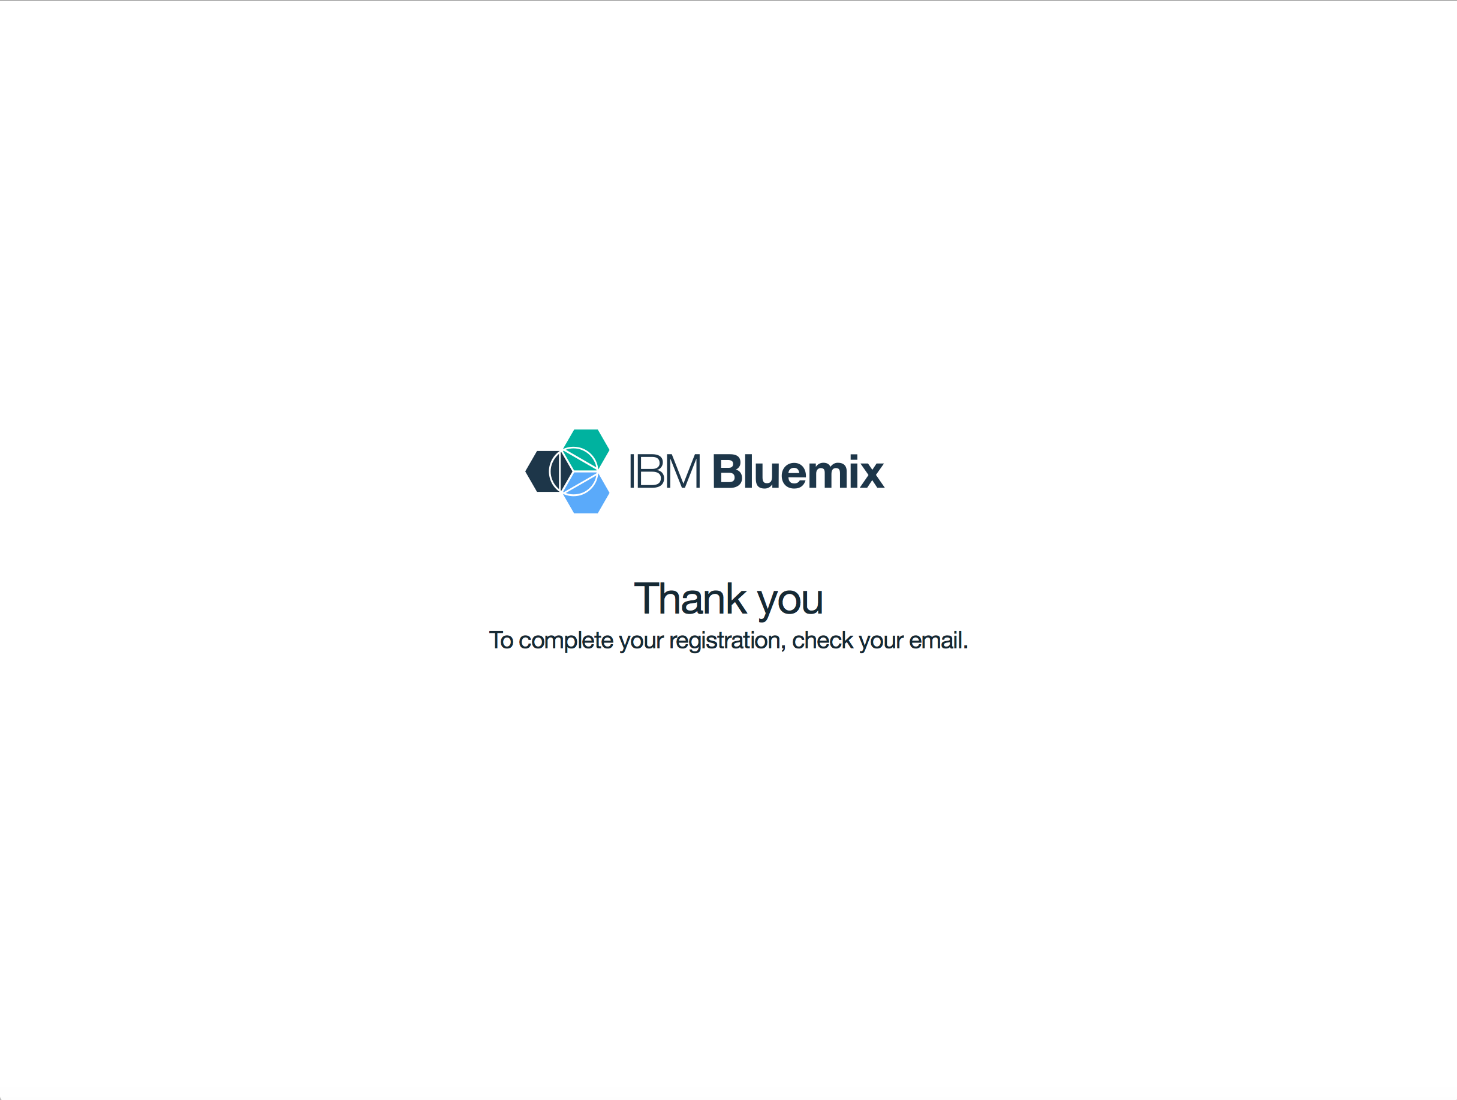

1. You will see the new emaill titled **Action required : Confirm your Bluemix account**. Open this email and click **Confirm Account**.
2. Now you finished registration. Congrats! Go to [**https://console.ng.bluemix.net/?direct=classic**](https://console.ng.bluemix.net/?direct=classic)and click **LOG IN**. Once you succeed to login, you will see the screen like below. To start using Bluemix you should setup your environemnt, which means 3 things that you should determine. Region to create the first space, Organization name, and Space name. Create your organization which is a term of team or project. You can invite your colleagues to your organization so that you can share resources and collaborate with them. Organization exist in geographic regions, and each region consists of different services. In this excersize, select **US South**.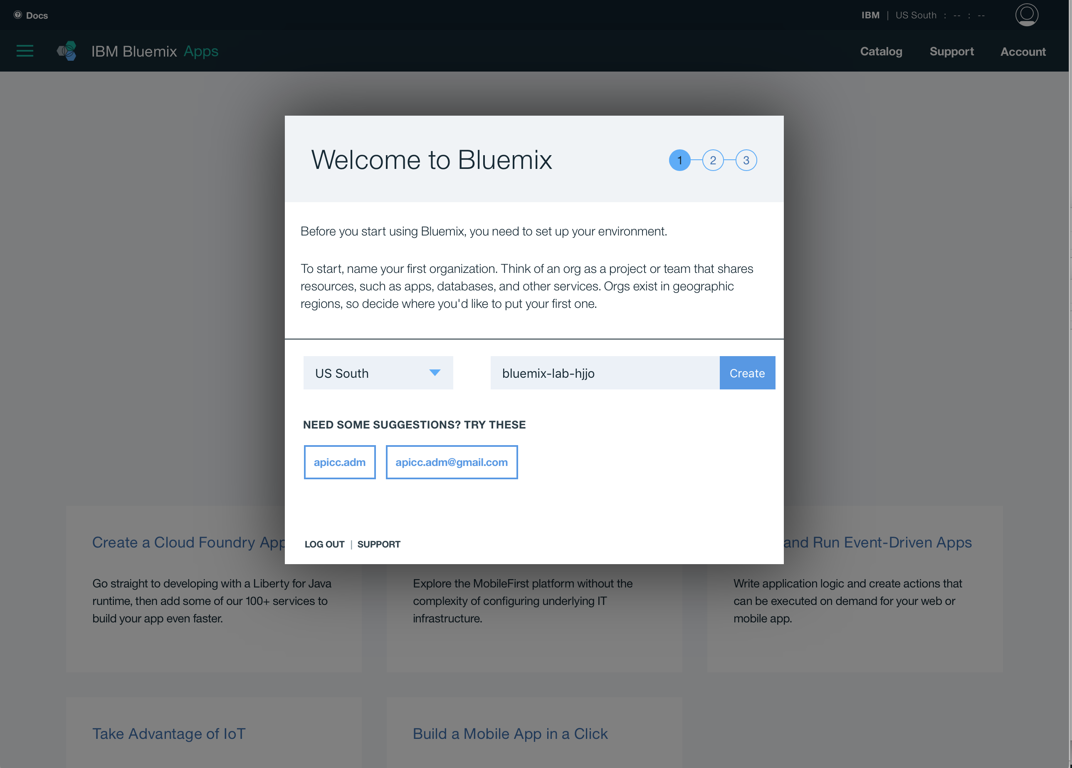
3. Name your organization and click **Create**. Be informed that organization name should be unique. 
4. Name your Space name as well. Space is that you can manage access and permissions on it and let your resources separated per your development stages. For example, you can have development, test and production spaces separated from each other for a project. Click **Create**.

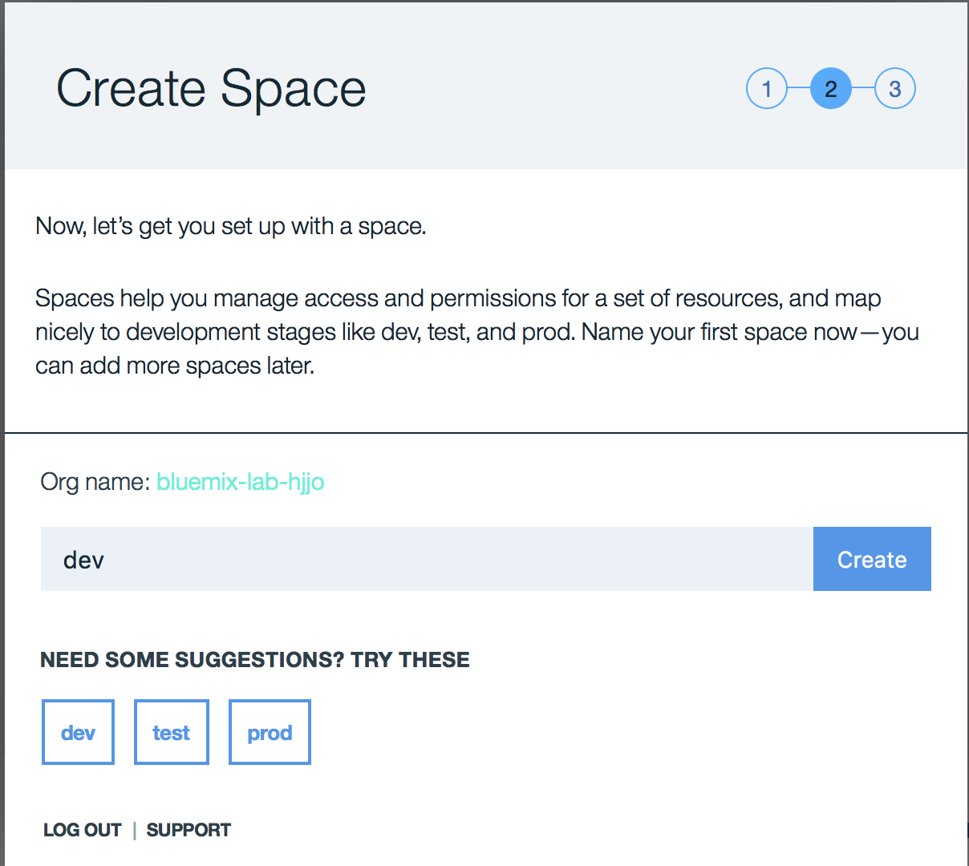

1. Now you finished to setup your environment. Click **I’m Ready**.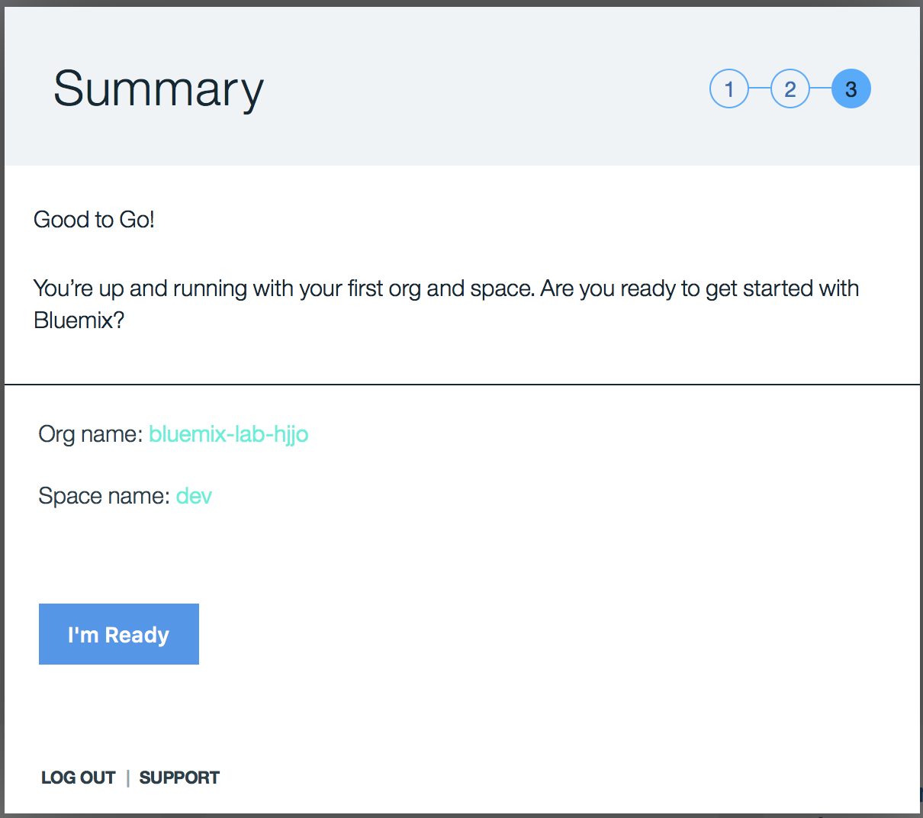
2. You may see this screen even though you created a space in the previous step ! This is because you are in the different region from the region that you created space. Click **Cancel** and let’s move to your preferred region. (If you don’t see this screen, skip the following steps and jump to step 15.)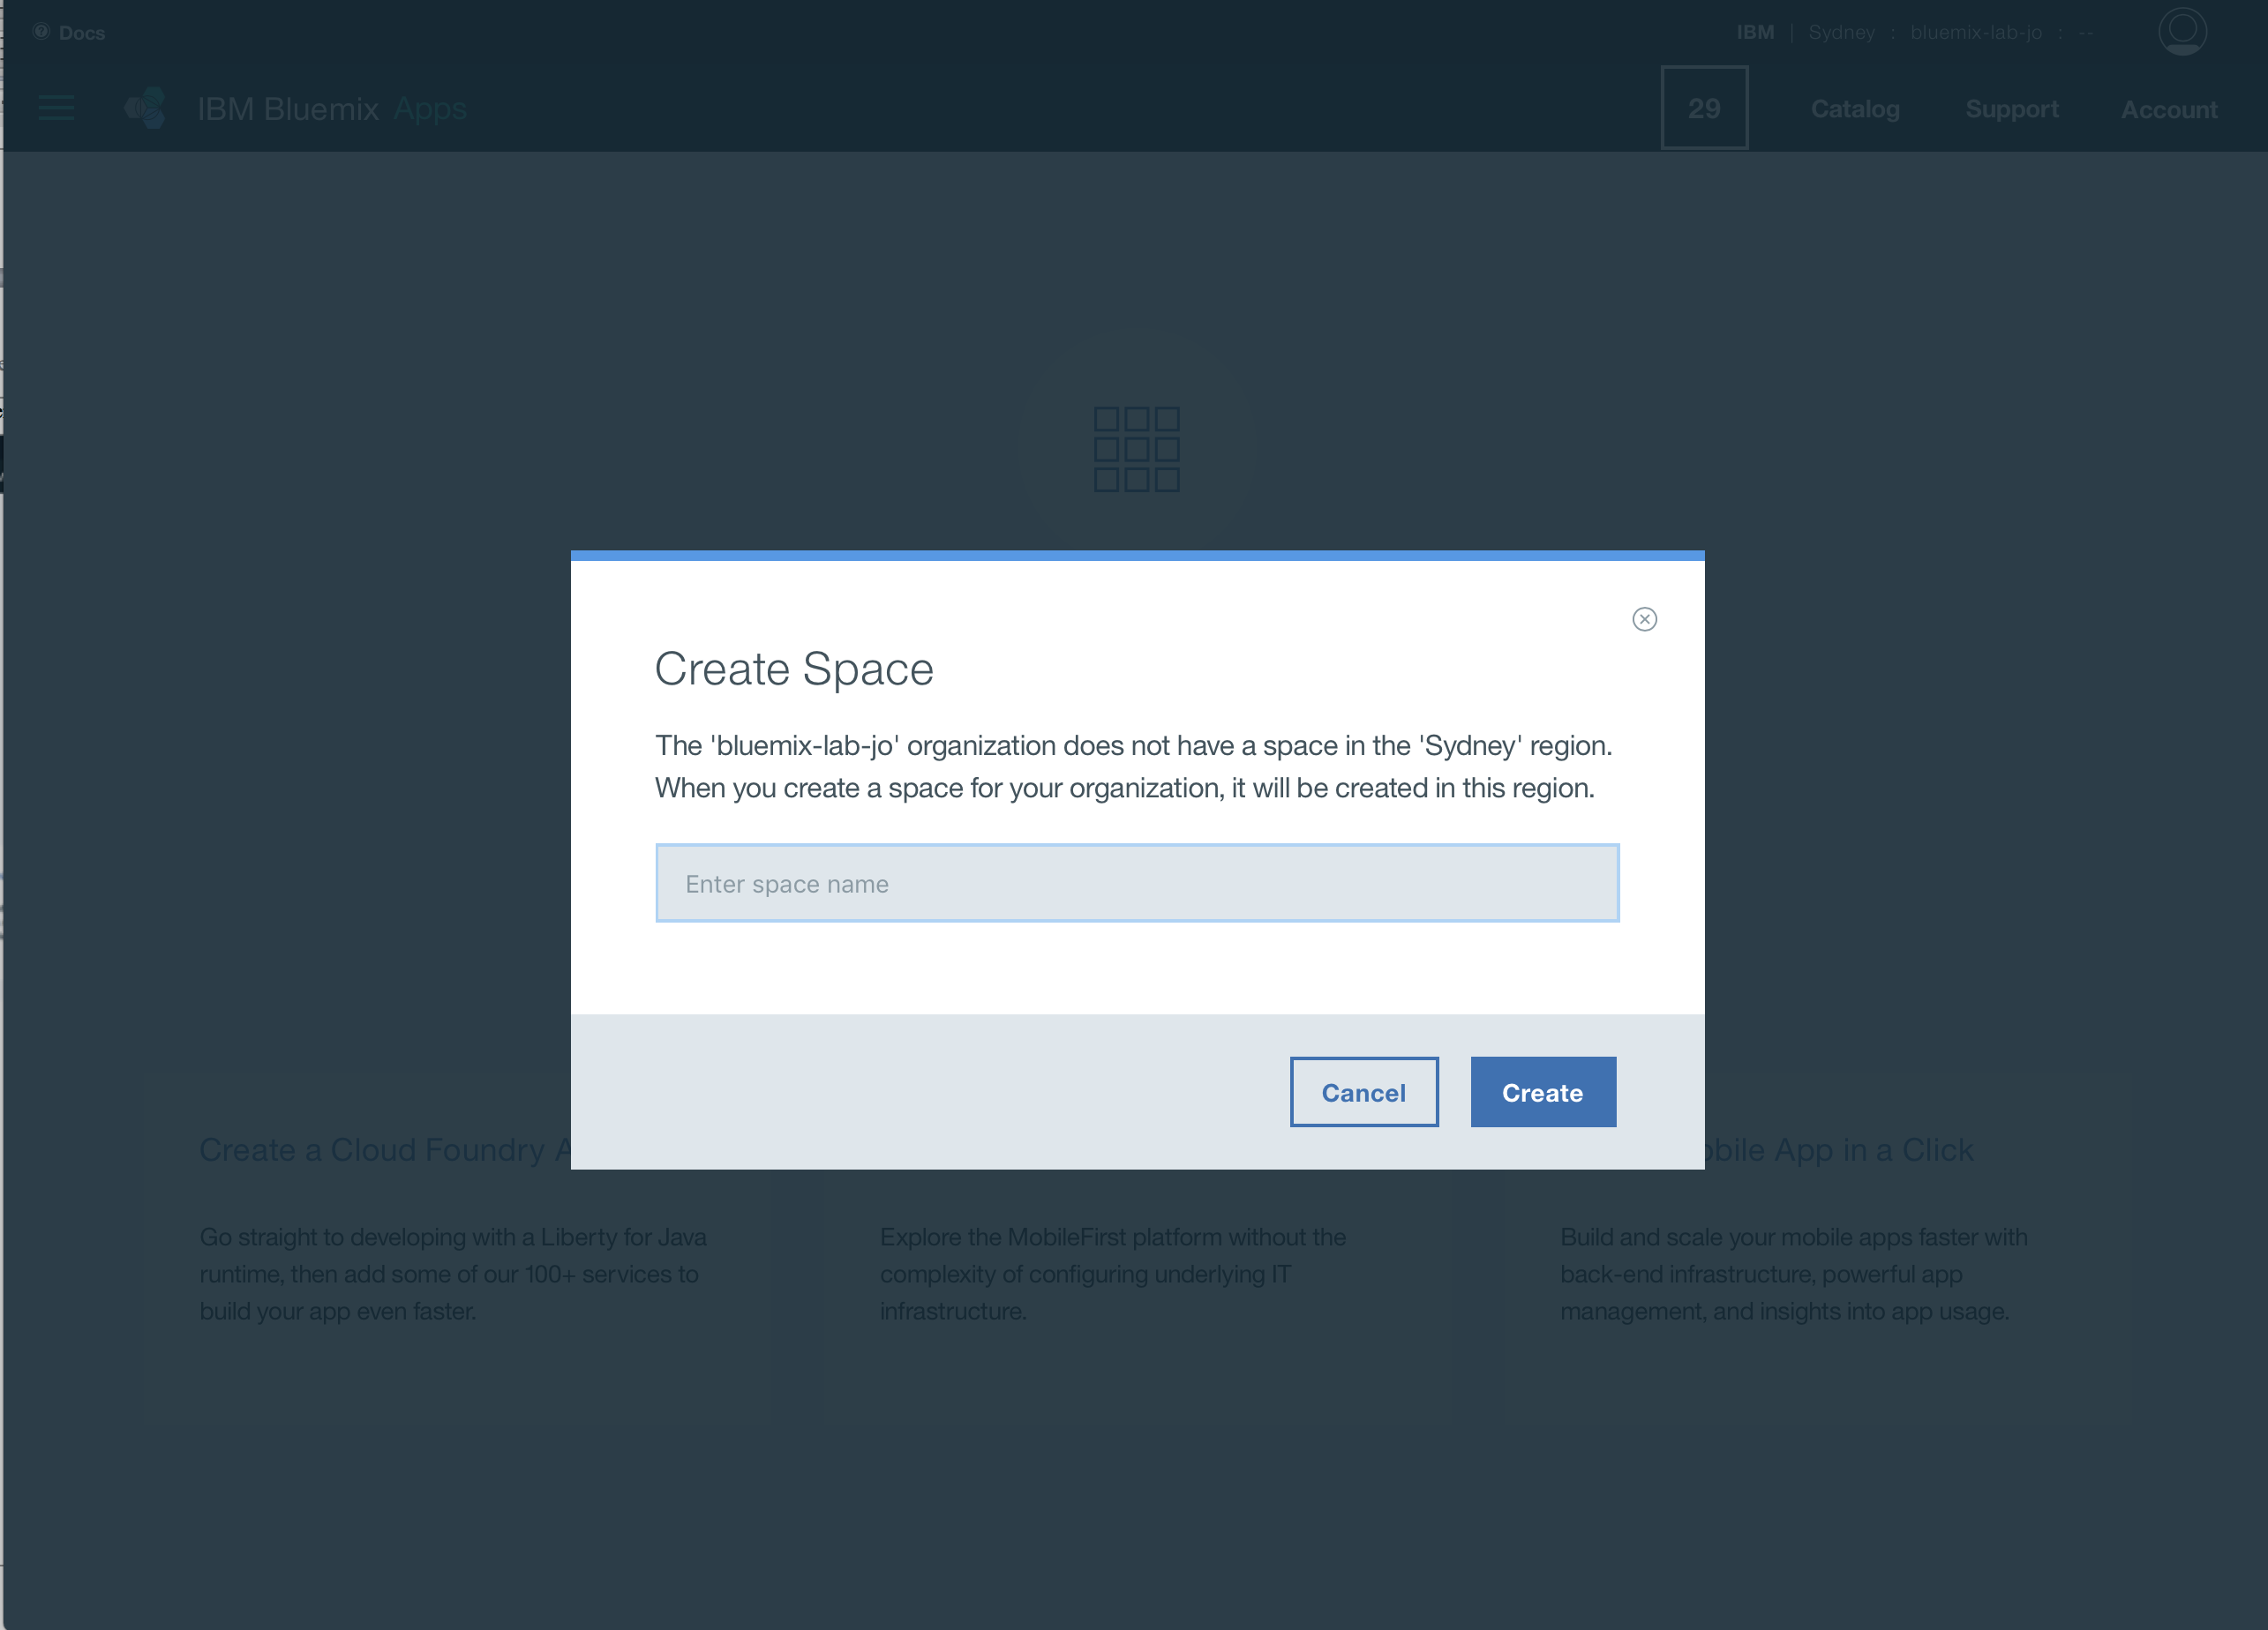
3. Click current region text at the right top corner.

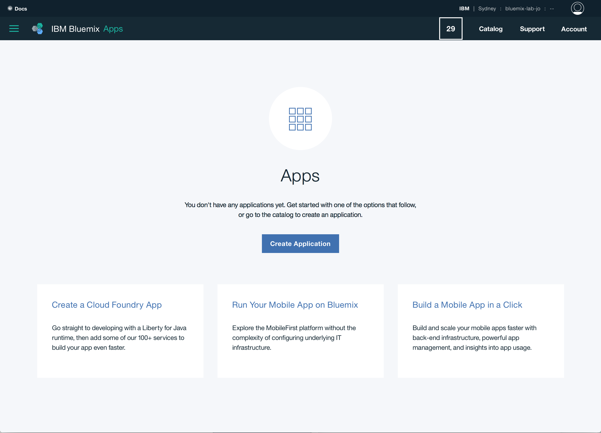

1. You can manage your region, organization and space here. Click **Region** select box and choose your preffered region. In this document, preffered region was **US South**.

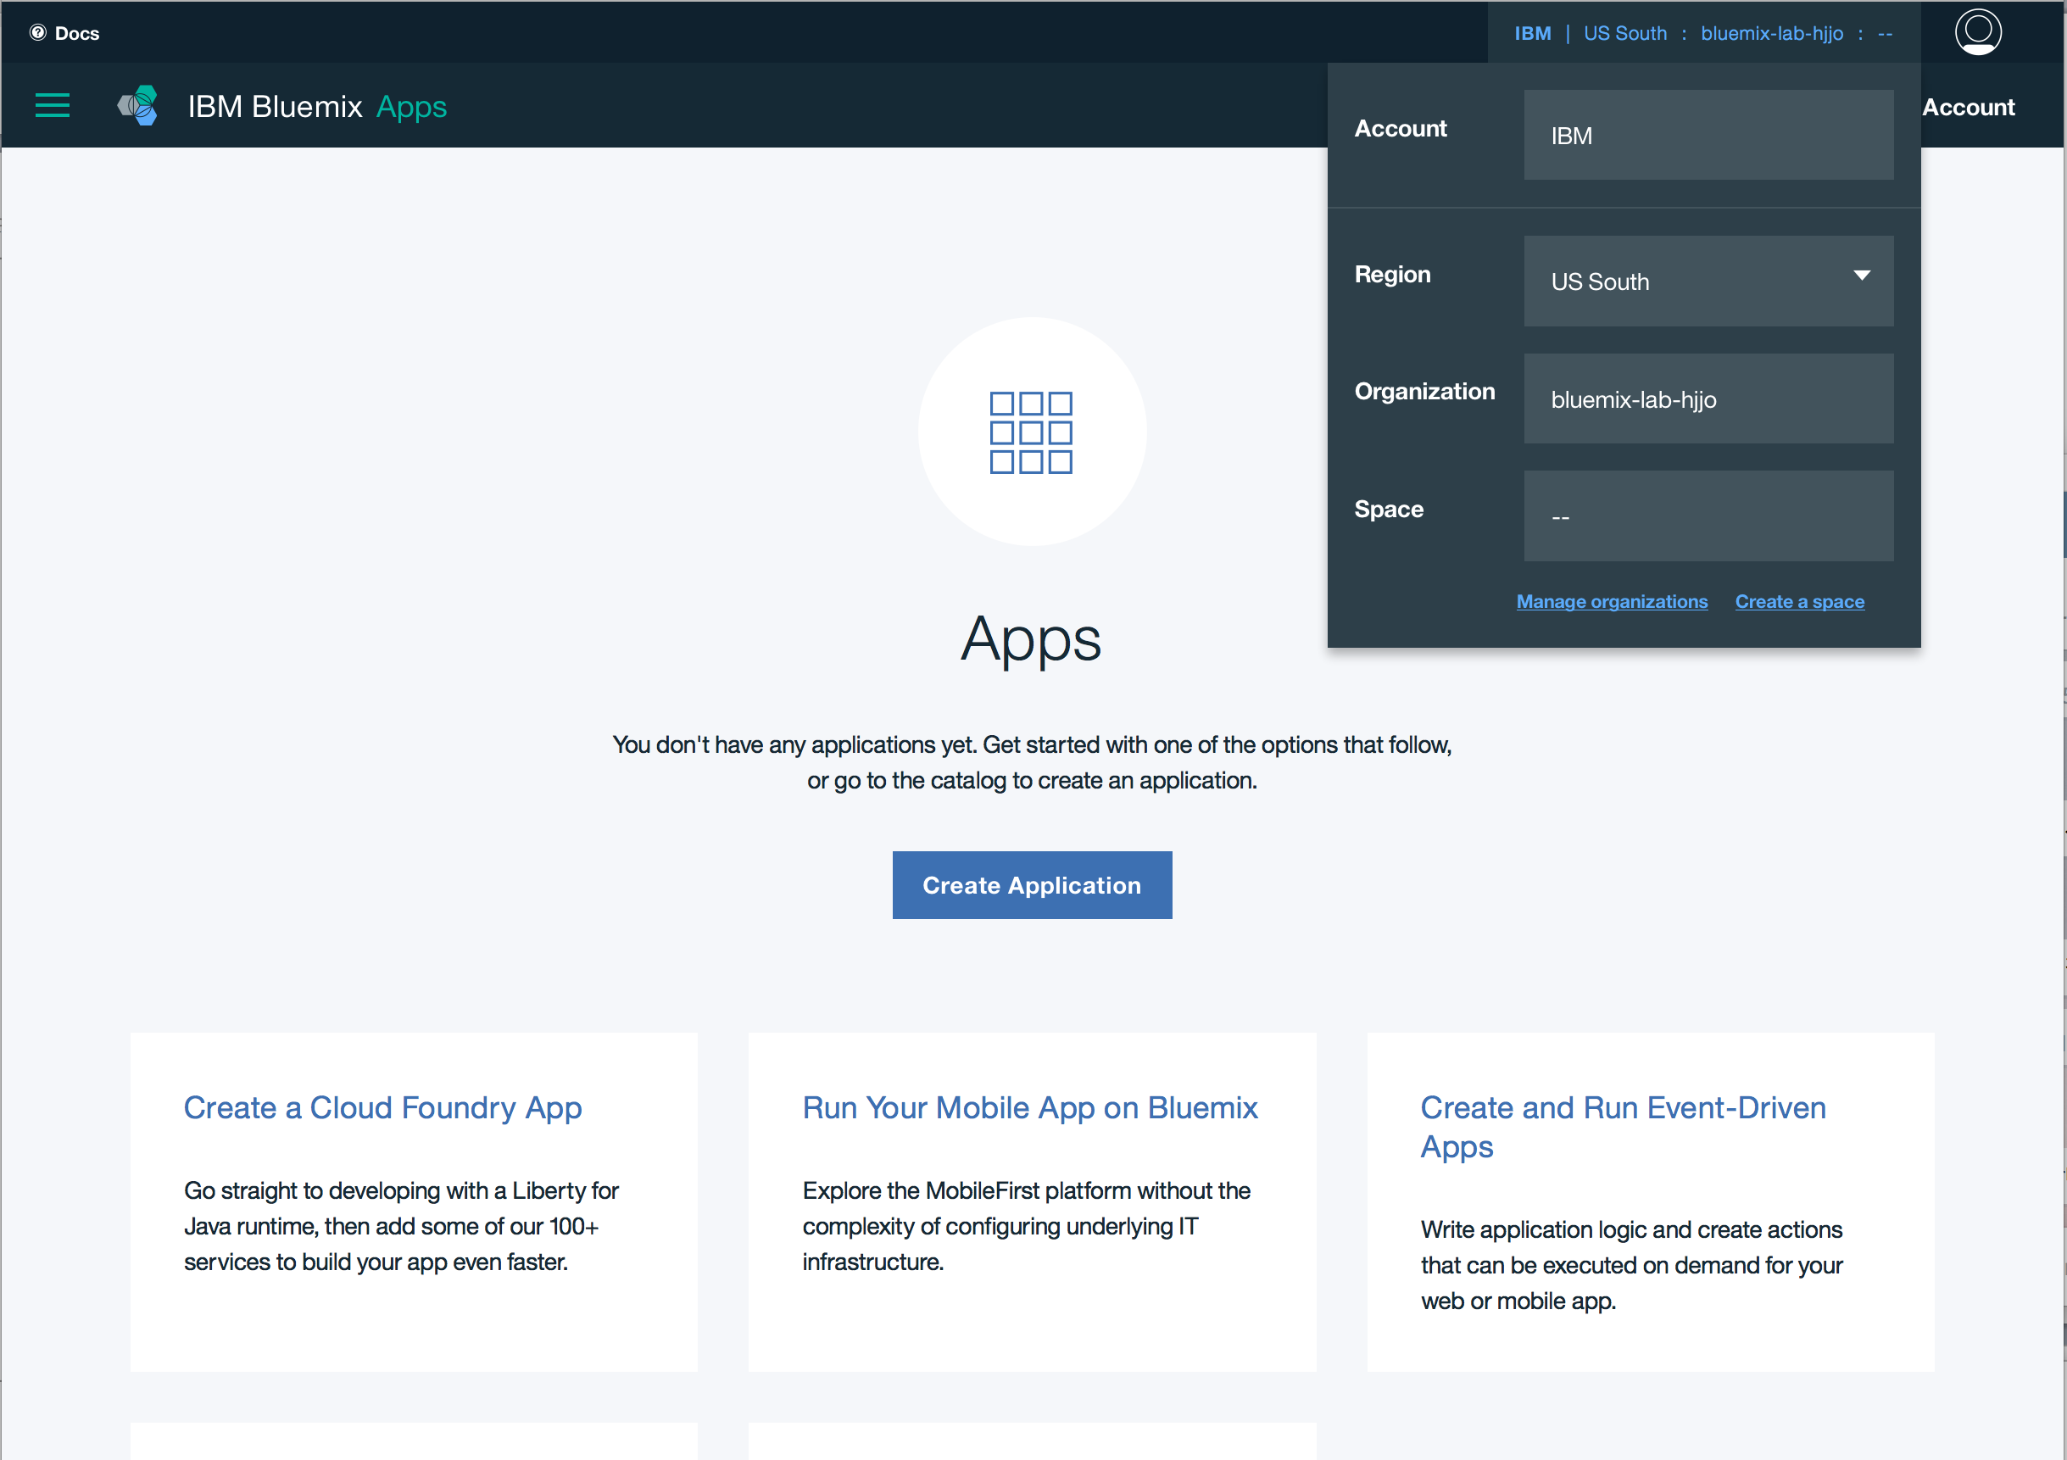

1. Now your registration is done and you can use bluemix environments !

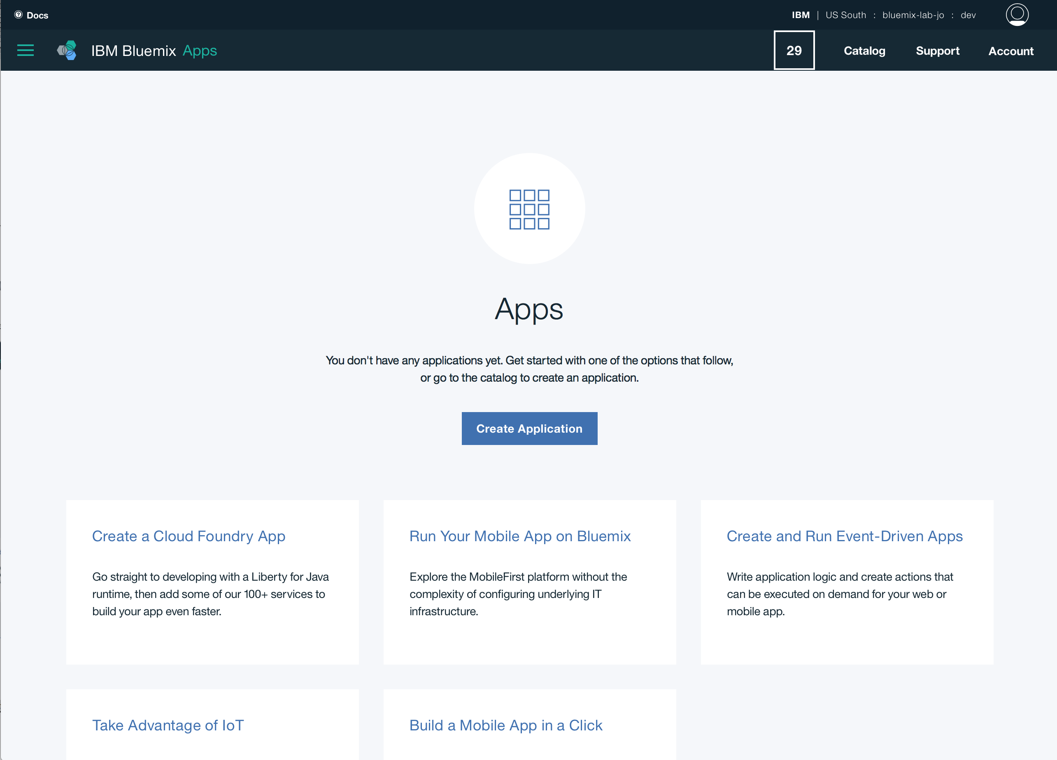

# PART 2: Install IoT Starter App on your smartphone

In this activity, you will install an IoT Starter App on your phone acting as IoT device.

1. To install the app on **iPhone** -
   * Open a browser and open this link:

https://ibm.biz/iotstarter

* + Click “For iPhone” and follow steps to complete installation.

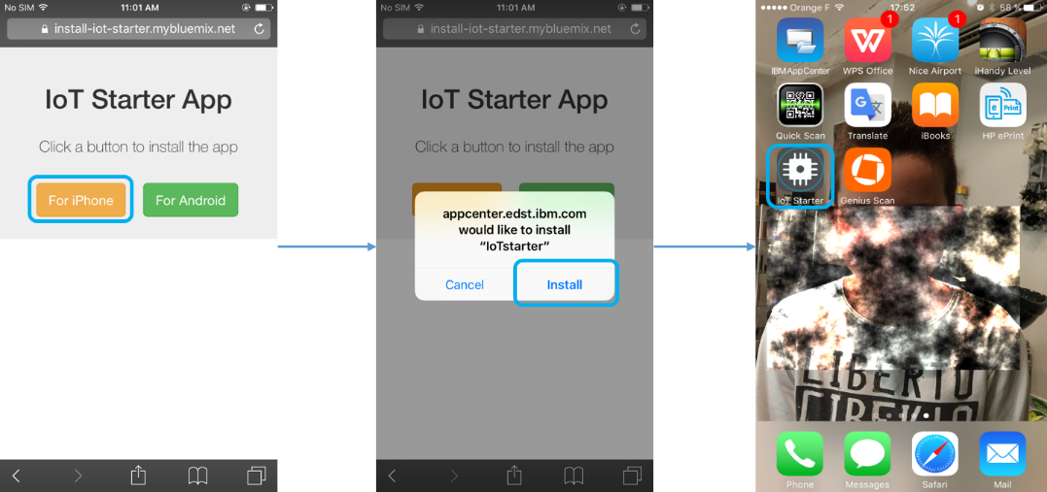

* + When using iOS 9+, if you see the following popup while starting the app the first time, go to Settings – General and follow steps below.

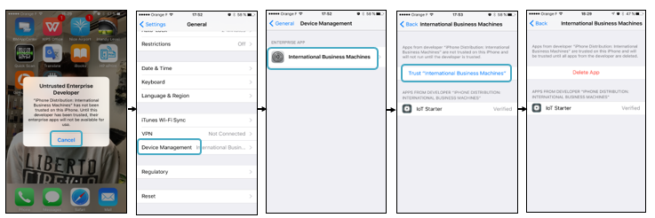

1. To install the app on **Android -**
   * Open a browser and open this link:

https://ibm.biz/iotstarter

* + Click “For Android” and follow steps to complete installation.

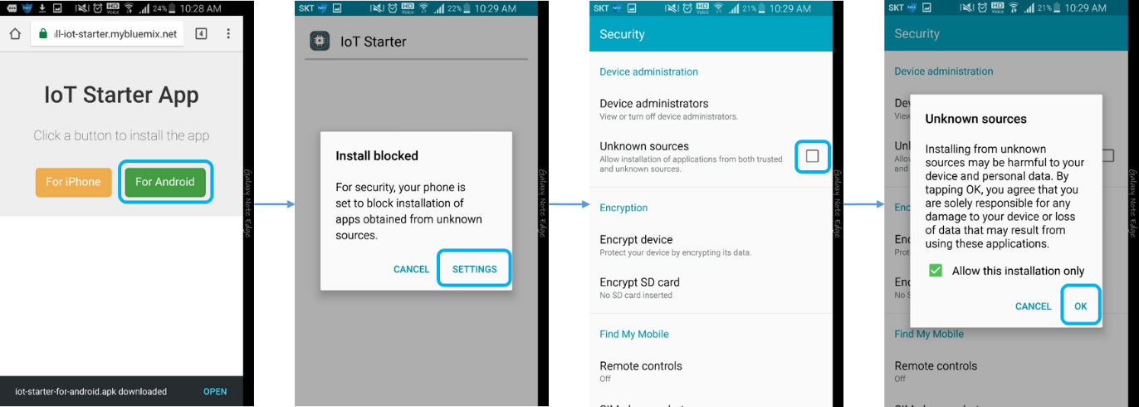

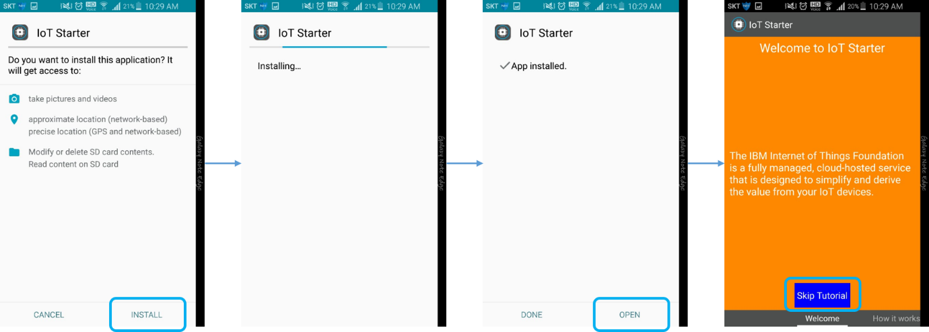

Congratulation! You have completed the pre-work.

|  |
| --- |
| **End of Document** |